CHIP600 mProject 7 Yannick Apedo

Poisson Regression Table

|  |  |  |  |  |  |  |
| --- | --- | --- | --- | --- | --- | --- |
|  |  |  |  |  | 95% CI for Odds Ratio | |
| Predictor | *B* | SE *B* | Δχ2 removal | Slope of the Predicted Wins | Lower | Upper |
| Constant | -0.490 0.0709 ---- ------ ----- ----- | | | | | |
| Seed | -0.196  0.0150 59.332 .822 .798 .847 | | | | | |
| Field goal percentage | 0.075 0.0239 203.955 1.078 1.028 1.130 | | | | | |
| Blocks | 0.059 0.0358 2.696 1.061 .988 1.138 | | | | | |
| Turnovers | -0.079 0.0358 4.809 .924 .862 .992 | | | | | |
| Graph 3 significant predictors: seed, field goal & turnover | | | | | | |

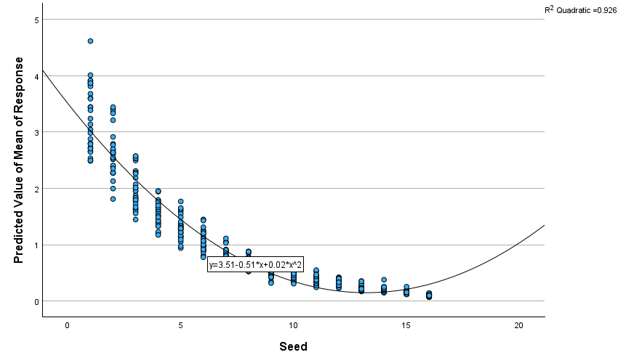

* Relationship between predicted wins (the actual count, which is analogous to the odds) and seed

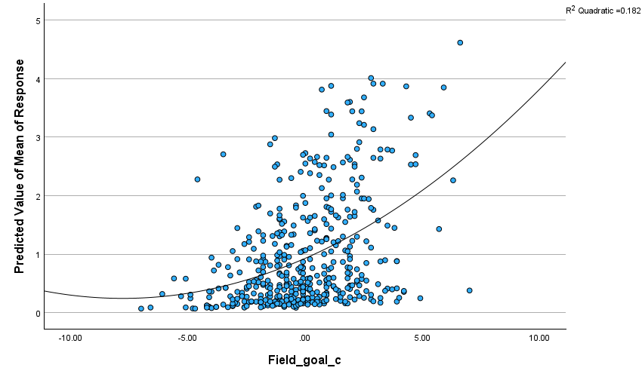

* Relationship between predicted wins (the actual count, which is analogous to the odds) and field goals made

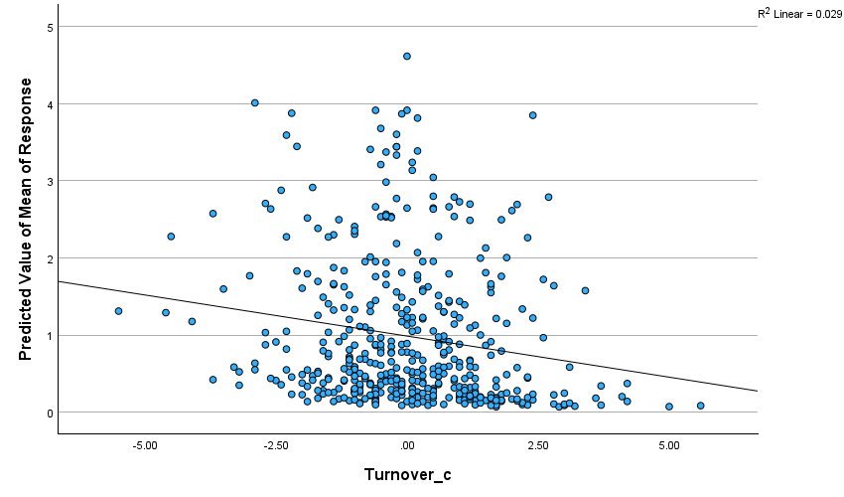

* Relationship between predicted wins (the actual count, which is analogous to the odds) and field goals made

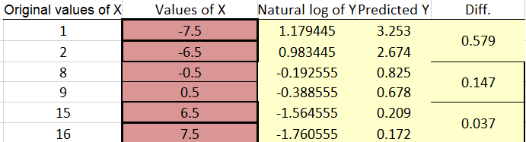

Report

Using data from each team’s NCAA tournament wins, the frequency of wins was not normally distributed. We used Poisson regression in order to handle count data. It should be noted that using traditional regression models, that use normal distribution, we may observe problems in modeling our dependent variables that were observed have a Poisson distribution (low values the most frequent observed while high values were the least frequent).

The number of wins was studied via the linear term applied in the Poisson models. The win rates, the rate ratios and their significance, and the percent reduction in the misfit of the model (indexed by the R2L) were computed. The expressed rate ratios were derived from the final models. The R2L value refers to the difference between the total deviance and the deviance of the studied model divided by the total deviance.

Overall, as displayed in the table, seed, field goal percentage, and turnovers helped to predict the number of NCAA tournament wins (excluding blocks as it did not reach significance). Interpreting the significant main effect for seed, we focus on the change in wins as seed increases using three representative seed values, 1, 8, and 15. The predicted number of wins when the seed for a team changes from 1 to 2 decreases by 0.579 (predicted wins for # 1 and 2 seeds = 3.253, 2.674, respectively). The predicted number of wins when the seed for a team changes from 8 to 9 decreases by 0.147 (predicted wins for 8 and 9 are .825 and .678, respectively). The predicted number of wins when the seed of a team changes from 15 to 16 decreases by 0.037 (predicted wins for 15 and 16 are .209 and .172, respectively).